Assignment 4

Name: Suryansh Sandeep Kumar Singh

Div.: B

Roll No: S1951122

PRN: 72018560C

Problem Statement:

Write a program to solve the travelling salesman problem and to print the path and the cost using Branch and Bound

Code:

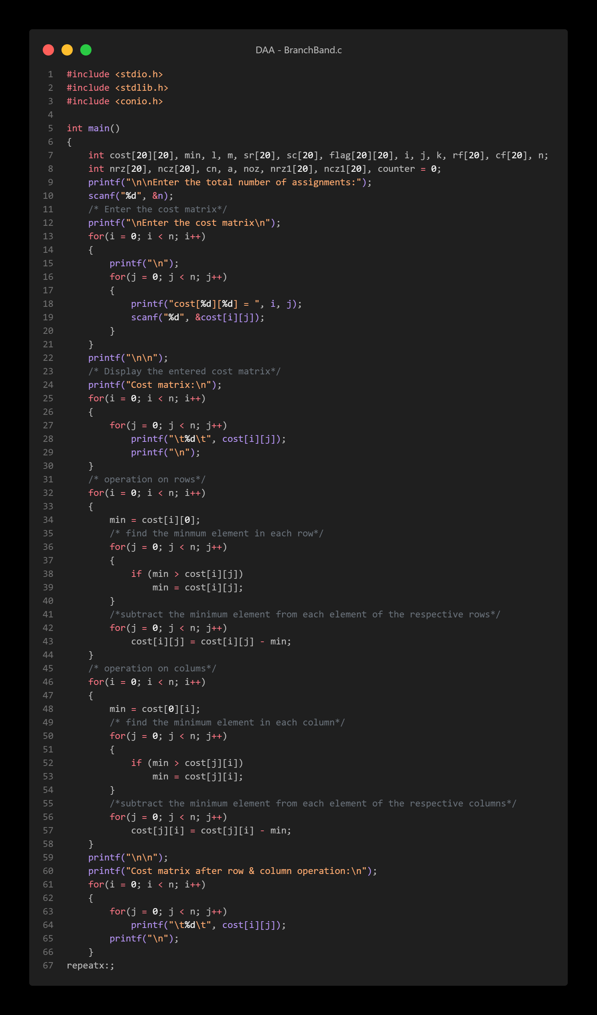

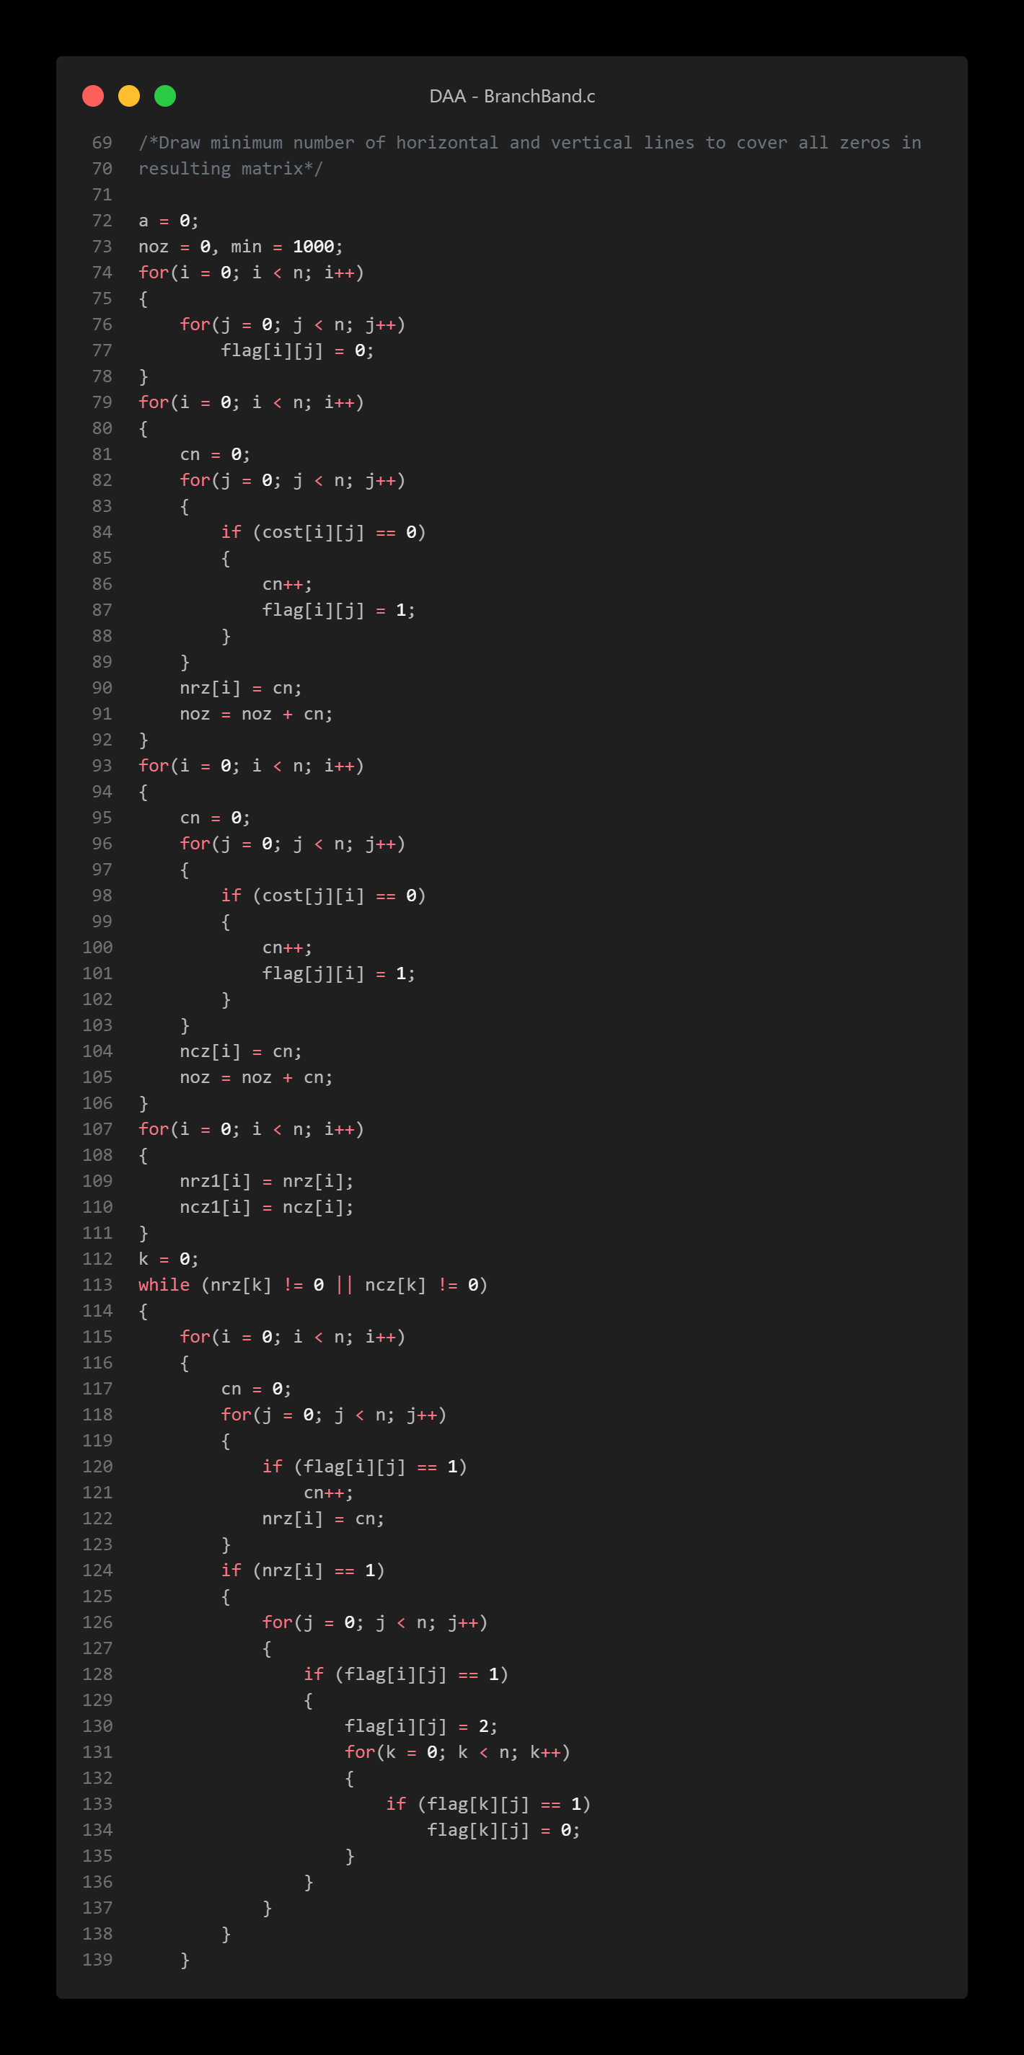

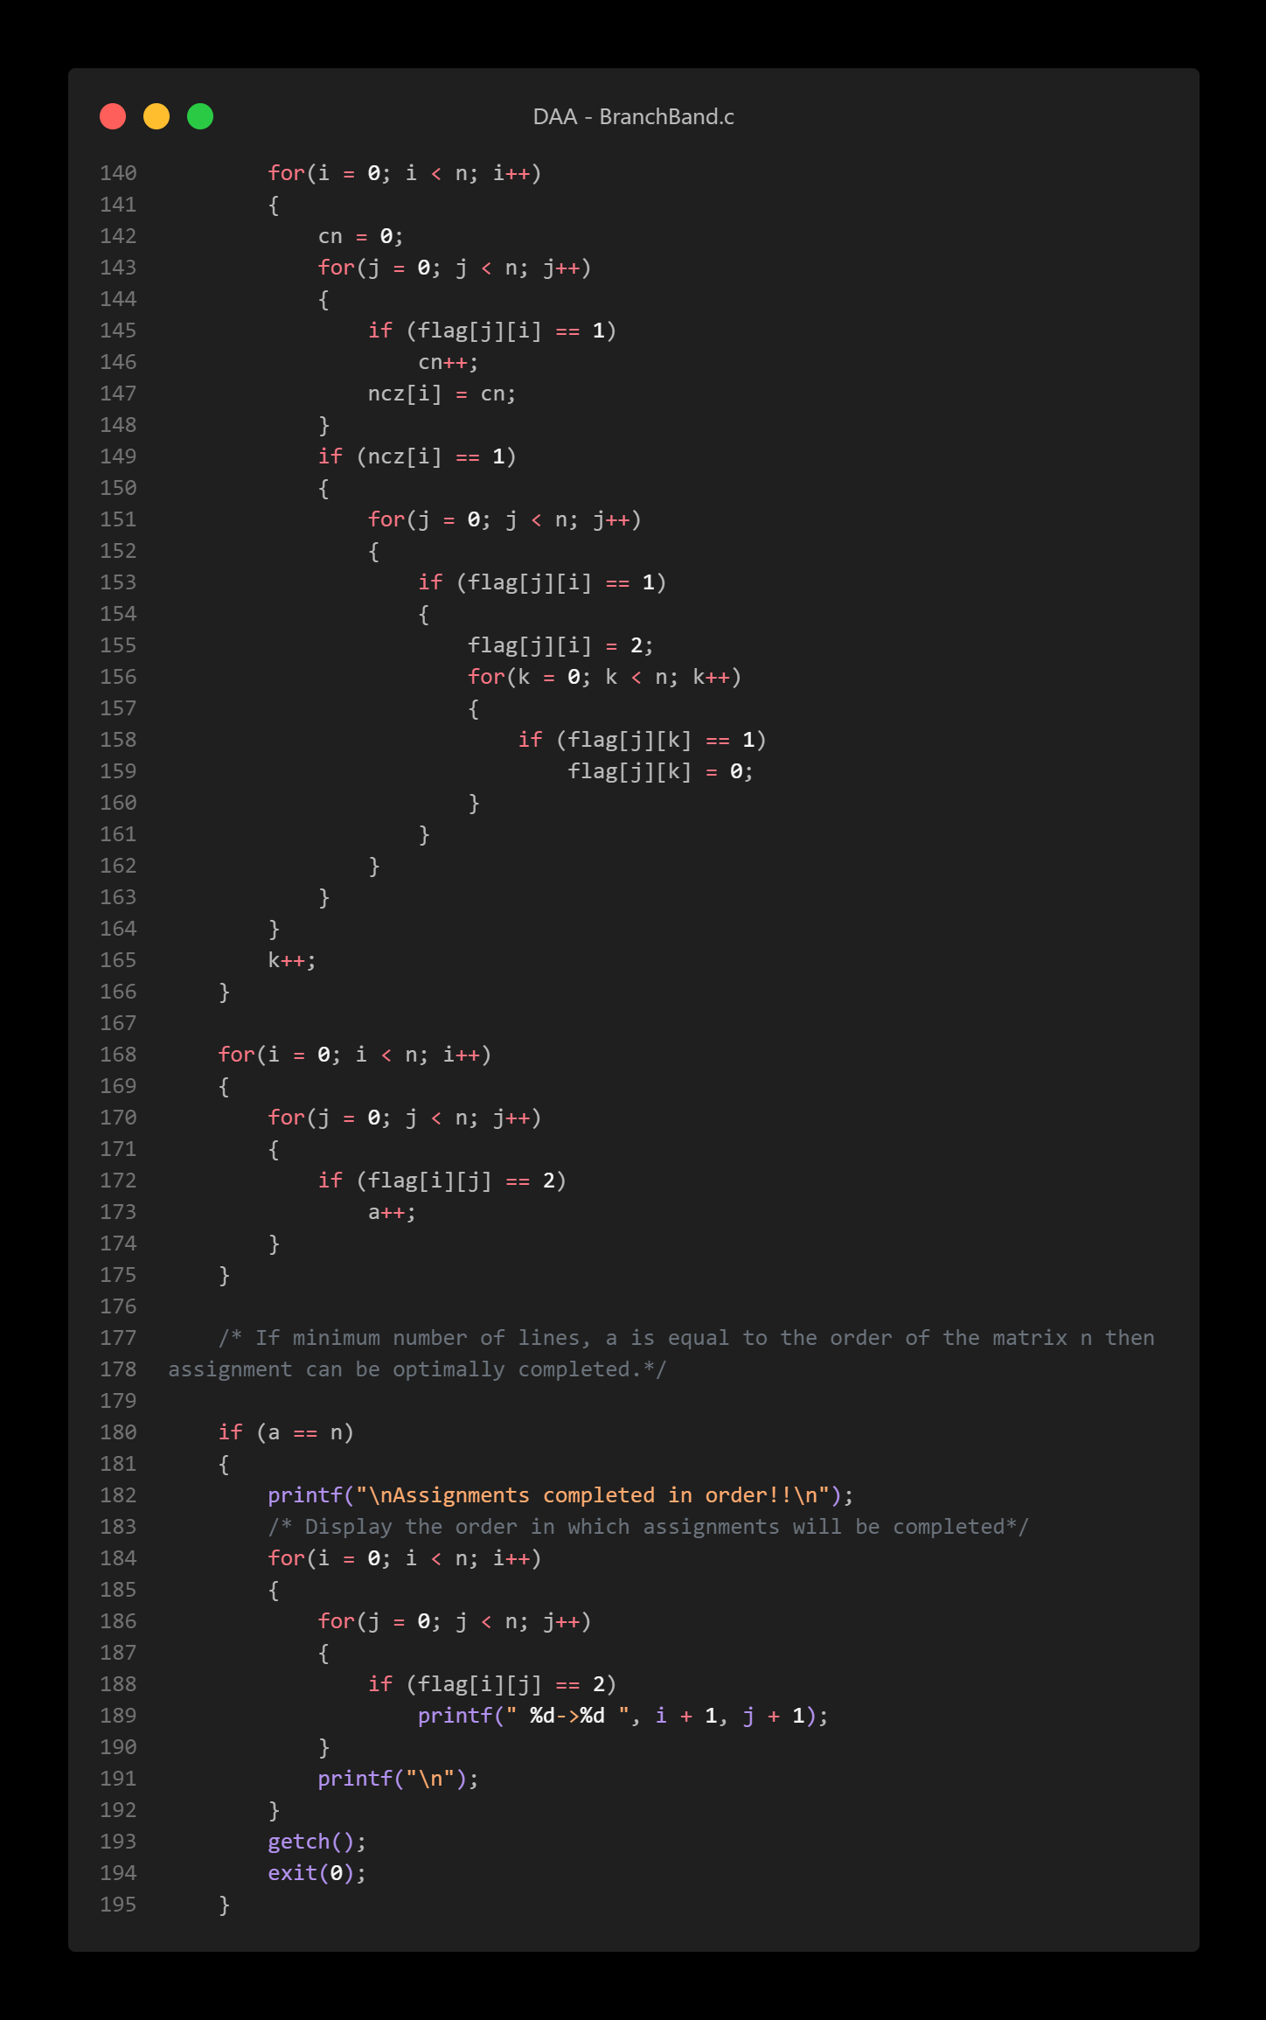

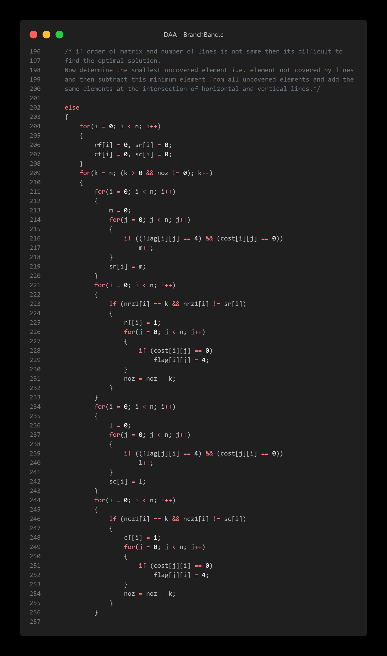

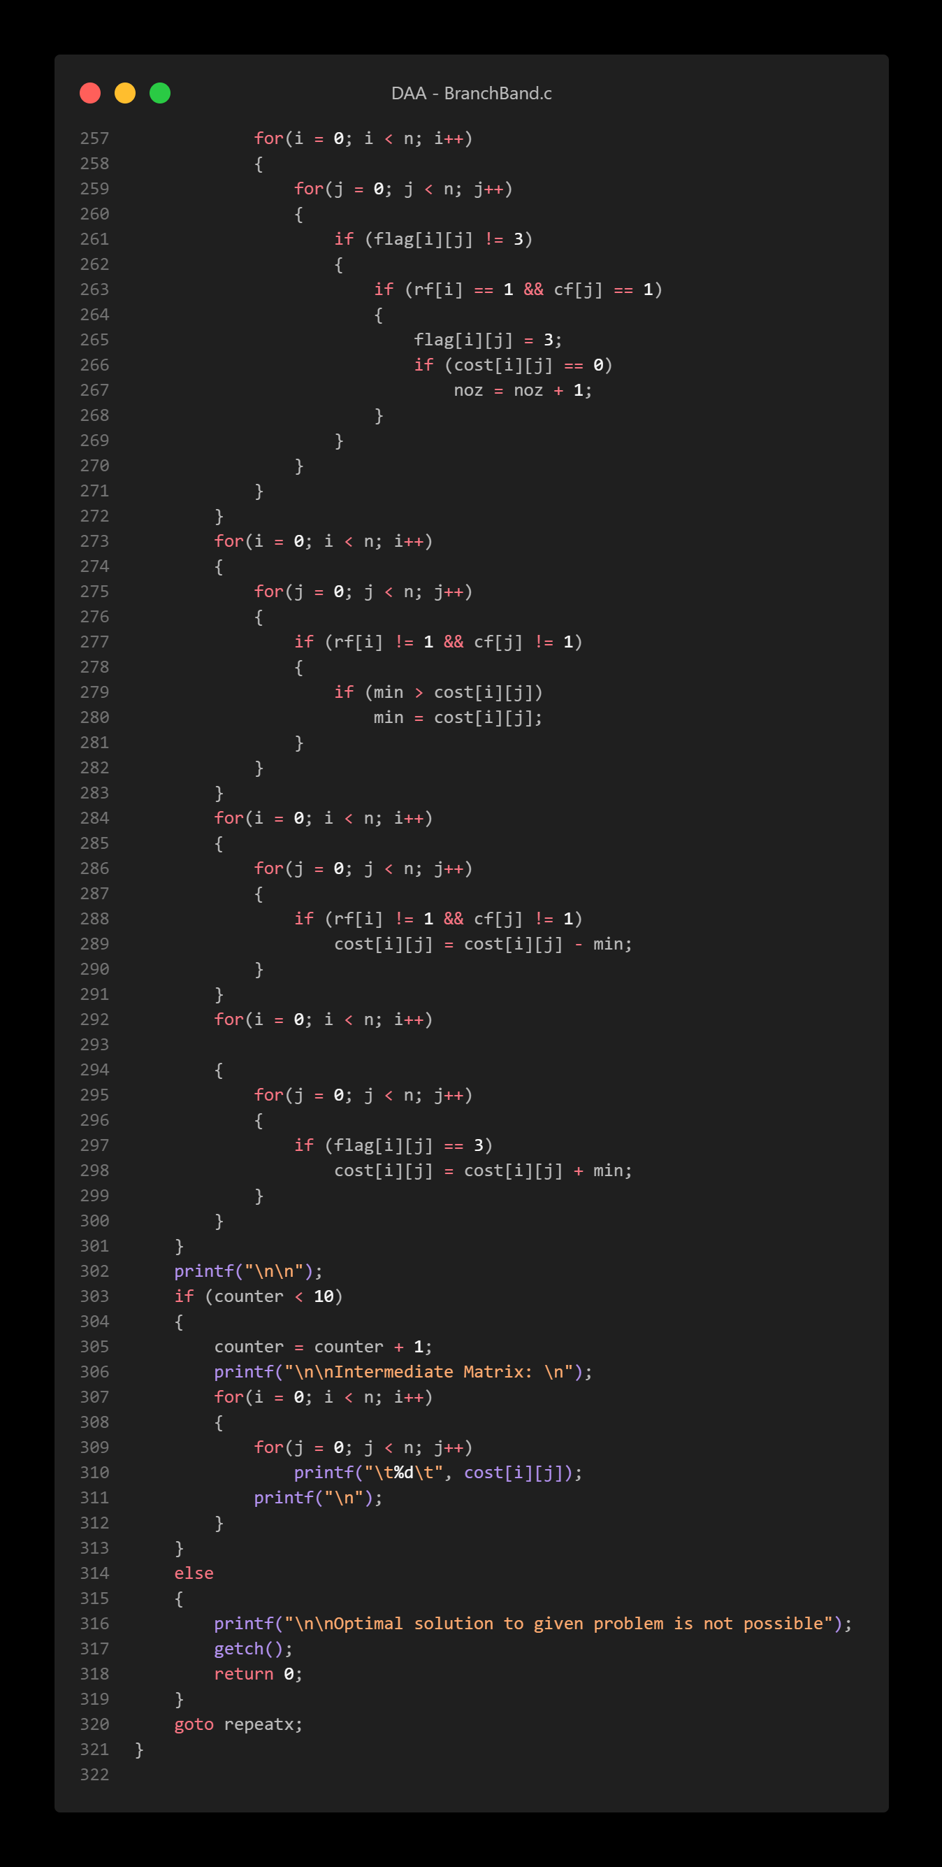

Output:

